Welcome to
By The Bay Cabin

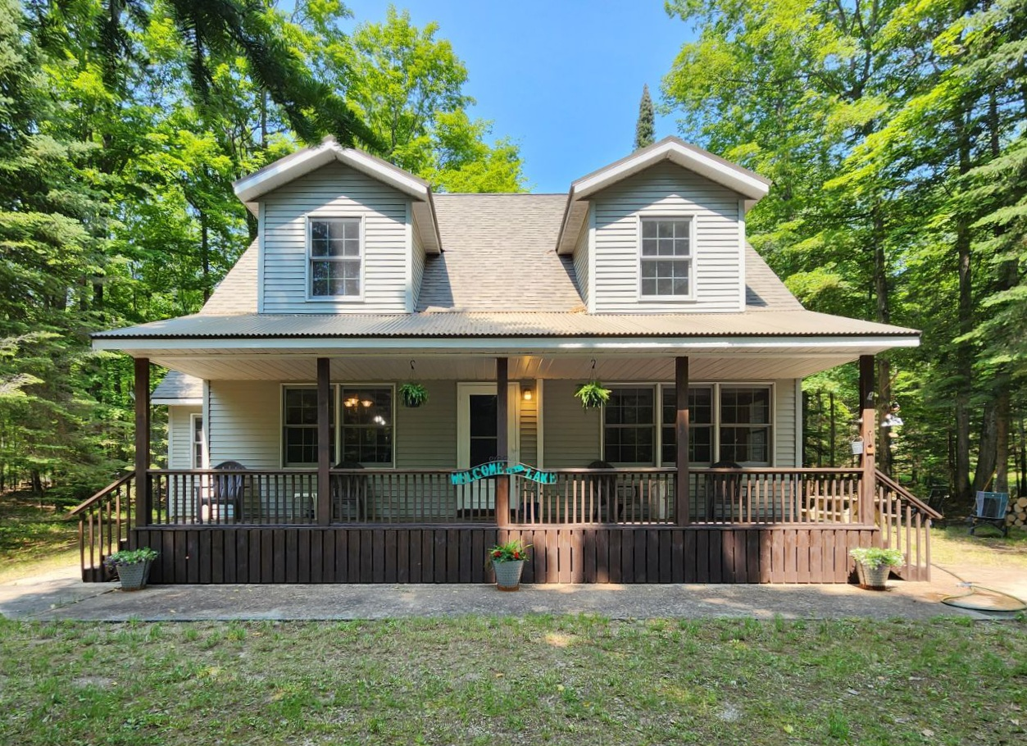
Welcome to our home! We purchased this home a few years ago and have been slowly renovating it every year. We hope you enjoy your time at the cabin like we do. Here's a few things you should know.

Heating & Cooling system:
We have electric heat as well as a Mini Split system for heating and cooling. The main living room and each bedroom has a mini split unit that you control with a remote. I have attached a picture with instructions on how to run these units. We ask that you do NOT use the electric heat ( which are the dials on the walls in each room ) as for it is extremely costly.

Furniture:
We ask that you do NOT put anything on the kitchen table, kitchen island or any of the furniture without a coaster or some way of protecting it. Most items we built ourselves and we do not want them getting damaged. Please whip down with a dry rag if water does get onto the furniture.

Fireworks:
With it being so heavily wooded we do NOT allow any fireworks of any kind.

Fires: We have added a small firepit to our outside area. Please see the info taped on the fridge regarding the open fire.

Smoking:
Absolutely NO smoking inside. If you do smoke outside, please make sure you properly extinguish and dispose of.

Animals:
We do not allow animals at our home.

Parties:
We do not allow large parties at our home. No bachelorette or bachelor parties at all. This is a quiet neighborhood and we try to respect all our neighbors. Quiet time is between 10pm & 7am per Antrim County ordinance.

Driving on road.

There is a strict 15 MPH speed limit on the private road to get to our home. Many children are out running outside, people biking or walking. There are a few blind corners so please be respectful and take your time. Nothing is so important that you may get into an auto accident or hurt someone.

Beach Access:

Unfortunately, we only have a very small beach which we share with our neighbors. The beach is for the owners and their families only. You can use the path to access the water to walk etc but the sitting chars, picnic table and swing are all privately owned and you cannot use them. If your looking for a beach day, 3 miles to the north on Old Dixie Hwy, is Antrim Park. It has a 1 mile public beach as well as wonderful hiking. You can also go to Barnes Park or Torch Lake which are both in Eastport.

T.V. Info:

We have either Ruku sticks or smart Tv’s in all living spaces. You will need to log your personal accounts to access features other than the free TV. Make sure you log out also when you leave!

WIFI is under Bobbi’s Place and Password is : 12680000

Linens:

There are extra linens for the futon beds in the closets in the bedrooms upstairs. The pullout sofa linens and pillows are in the master bed closet.

Misc info:

This area tends to lose power frequently do to the heavy woods. Generally, it comes back on within a few hrs.

We have a gas grill available for your use. Please clean all utensils and turn off the gas when you are done.

We can be reached at 303-918-1942 or my co-host Kim at 1-231-357-7087
Check out responsibilities of Guests

- Please remove all food from refrigerator, freezer and cupboards.

- Remove all trash and debris from the home, yard area. Deposit the trash in the bin at the end of the driveway. ( Trash day is picked up every Friday)

- Make sure all dishes are placed in the dishwasher and start the dishwasher.

- If you used the grill please confirm the gas has been shut off.

- Leave all towels in the bathtub or set on top of the washer.

- Please do not strip the beds or pillows

- Please check under beds and furniture for personal items

- Make sure all TV remotes are out back by TV and you are logged out of all streaming accounts.

- Close all windows and lock all doors. Use your personal code to lock the front door.

- Turn off all lights

- If personal property is left behind and is necessary for the items to be returned, we will ship for $10.00 + COD.

Thank you! We hope you enjoyed the home and area as much as we do and we hope to have you return again!

Where to eat?

Our location has it’s benefits when you want to go away and have some good quiet time, however with that the places to eat are not as varied like you would be in the city. Here is a few places close by that we have been too and enjoy.

Torch Lake Café is the closest restaurant / bar to our home. They serve the best Olive Burgers around “if you ask me”. They have live music throughout the year. Approx 4 miles away.
Their address is:
US-31 N. Central Lake, MI 49622
(231) 599-1111
Website:torchlakecafe.com

Bier’s Inwood Brewery is a great place to relax and grab a pizza and a drink after a long day of playing in upper MI. Located 6 miles south of Charlevoix with a beautiful view of The Bay. They have live music all summer. Pizza is very good!
Their address is:
17959 Ferry Rd
Charlevoix, MI 49720
1-231-675-7632
Website: biersinwoodbrewery.com

Friske Farm Market is a local family-owned business. They have a café serving breakfast goodies as well as fresh market to get the best Cherries around. Once your done eating they have a small gift shop you can get your MI souvenirs from. If you have kiddos they can play in the outside Noahs Ark or as a family go pick your own fruit off the plant yourselves! Approx 5 miles away
Their address is:
10743 US-31 Ellsworth, MI 49729
PH: 231-599-2604
Website: Friske.com

Providence Organic Farm, Café & Natural Market: is another local market selling fresh vegis, meats. They also have the best French pastries. Enjoy a coffee while overlooking their beautiful farm. Approx 5 miles away.
Their address is:
5695 N. Michigan 88 Central Lake, MI 49622
Website: www.csafarms.org

The Villager Pub: Family favorite for white fish and chips. Family has been going here for 20 yrs and it never disappoints. Fun atmosphere with seating right on the main street Charlevoix. After your full go walk the beautiful town of Charlevoix. Maybe grab some Ice cream or Fudge from local store.
Their address is:
427 Bridge St Charlevoix, MI
1-231-547-6925
Website:thevillagerpub.com

Bridge Street Tap Room: After a long day of shopping or adventures sitting down to a cold drink may be right up your alley. Tap room serves local craft beers as well as a great menu of bistro style food. Relax while over looking Round Lake in the heart of Charlevoix MI.
Their address is:
202 Bridge Street Charlevoix, MI 49720
PH: 1-231-437-3466
Website: www.bridgestreettaproom.com

There are so many wonderful places to eat in our neck of the woods that I could not possibly write them all down but these are a few of our favorites when we stay at the house. I hope you enjoy!

Things to do while visiting:

So many things that I could never even begin to scratch the surface. From a trip up to Mackinac Island or down to Traverse City for the Cherry Festival there are endless things to experience. I would say to visit every local towns website for what events they have going or upcoming. I know Charlevoix as well as Elk Rapids have weekly farmers markets I like to hit. Festivals are all summer and it’s what weekend you are there that decides what Festival you’ll go to. I hope you enjoy your stay in beautiful MI! I know we love it!

Public Beaches & Boat Launch

There is a wonderful beach at Torch Lake just a few miles from here. You can also get to the beach from Antrim Creek Natural Area. You can launch your boat at Torch Lake or Barnes County Park.

Please return all games after use! The corn hole game is NOT water proof and will get damaged if it gets wet.

Thank you

